Sql curso

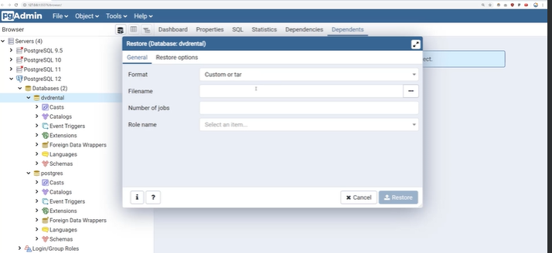

SELECT customer_id,SUM(amount)

FROM payment

WHERE staff_id = 2

GROUP BY customer_id

HAVING SUM(amount) > 110;

SELECT COUNT(*) FROM film

WHERE title LIKE 'J%';

SELECT first_name,last_name FROM customer

WHERE first_name LIKE 'E%'

AND address_id <500

ORDER BY customer_id DESC

LIMIT 1;

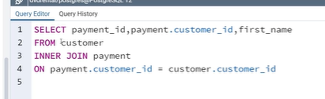

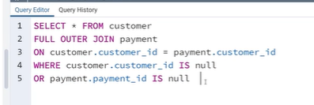

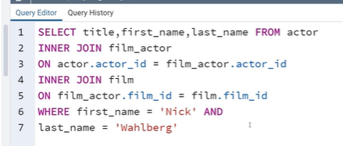

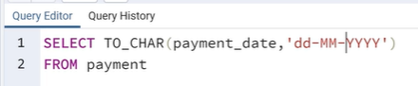

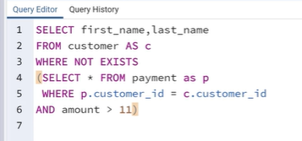

SELECT facid, name, membercost, monthlymaintenance

FROM cd.facilities

WHERE membercost > 0 AND

(membercost < monthlymaintenance/50.0);

SELECT * FROM cd.facilities WHERE name LIKE '%Tennis%';

SELECT * FROM cd.facilities WHERE facid IN (1,5);

SELECT memid, surname, firstname, joindate

FROM cd.members WHERE joindate >= '2012-09-01';

SELECT facid, sum(slots) AS "Total Slots" FROM cd.bookings WHERE starttime >= '2012-09-01' AND starttime < '2012-10-01' GROUP BY facid ORDER BY SUM(slots);

SELECT facid, sum(slots) AS total_slots FROM cd.bookings GROUP BY facid HAVING SUM(slots) > 1000 ORDER BY facid;

SELECT cd.bookings.starttime AS start, cd.facilities.name

AS name

FROM cd.facilities

INNER JOIN cd.bookings

ON cd.facilities.facid = cd.bookings.facid

WHERE cd.facilities.facid IN (0,1)

AND cd.bookings.starttime >= '2012-09-21'

AND cd.bookings.starttime < '2012-09-22'

ORDER BY cd.bookings.starttime;

SELECT cd.bookings.starttime

FROM cd.bookings

INNER JOIN cd.members ON

cd.members.memid = cd.bookings.memid

WHERE cd.members.firstname='David'

AND cd.members.surname='Farrell';

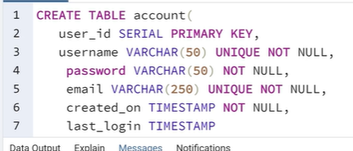

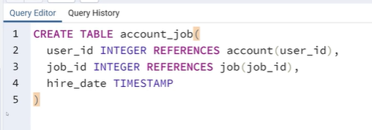

CREATE TABLE students(

student_id serial PRIMARY KEY,

first_name VARCHAR(45) NOT NULL,

last_name VARCHAR(45) NOT NULL,

homeroom_number integer,

phone VARCHAR(20) UNIQUE NOT NULL,

email VARCHAR(115) UNIQUE,

grad_year integer);

CREATE TABLE teachers(

teacher_id serial PRIMARY KEY,

first_name VARCHAR(45) NOT NULL,

last_name VARCHAR(45) NOT NULL,

homeroom_number integer,

department VARCHAR(45),

email VARCHAR(20) UNIQUE,

phone VARCHAR(20) UNIQUE);

INSERT INTO students(first_name,last_name, homeroom_number,phone,grad_year)VALUES ('Mark','Watney',5,'7755551234',2035);

INSERT INTO teachers(first_name,last_name, homeroom_number,department,email,phone)VALUES ('Jonas','Salk',5,'Biology','jsalk@school.org','7755554321');



